Simple Rule-Based Chatbot Using Python and Google Colab
Introduction
Artificial intelligence technologies have changed the way human beings interact with machines. Across the world, one single technology is gaining considerable popularity and that technology is chatbots. Chatbots are gaining popularity in education, health care and customer service, banking and e-commerce. A chatbot is software that can imitate human speech in text or audio in handy interactive form. Chatbots can range from a simple heuristic chatbot following a set of explicit rules, to an advanced artificial intelligence solution powered by machine learning and large language models.

While artificial intelligence has made some advances, rule-based chatbots are still important because they are very simple, reliable and easy to implement. Rule-based chatbots utilize pre-set rules that determine their responses based on a fixed set of inputs. They are an efficacious solution for repeating tasks as well as structured conversations with the result of a predictable answer (Qualimero, 2026; Moin AI, 2026). Rule-based systems are easy to design and maintain compared to other advanced AI systems as it doesn’t usually need huge data sets and extensive computations (Rule Based Chatbot Design Methods: A Review, 2025).
This project was designed to develop and implement a simple chatbot through the Python programming language. Using the Google Colab platform, users can author and execute code in the browser using Python programming language. The chatbot was developed using this platform. The chatbot accepts user instructions, gives information about its features, and responds correctly to invalid or poorly formatted instructions as well. Additionally, the chatbot underwent testing, with documentation done thereafter and the source code being stored in GitHub
This project is intended to showcase fundamental ideas in a Chatbot Development. Conditional Statements, User Involvement, Looping, Input Validation, Software Testing. Even though it’s quite basic, the chatbot provides a solid understanding of how conversational systems work and how advanced AI-driven chatbots could work in the future.
Development Environment and Tools
This chatbot project was developed using a variety of technologies and tools.
Python Programming Language
The main programming language was chosen as Python due to its simplicity, readable and provide developers with excellent support. There are many tasks for which we can use python programming language like Artificial intelligence, Automation, Data science, Web development etc. According to Python Software Foundation (2025), the programming language has a wide variety of libraries and in-built functions that make developing software easy and suitable for both novice and experienced developers.
Google Colab.
The development environment of this project was Google Colab. Using Google Colab, a developer can create and run Python notebooks online without having to install anything on their desktop. The platform effectively integrates executable code, documentation, and output results into the same environment, which can beneficial for educational and research purposes (Google Developers, 2025).
The use of Google Colab provided several advantages, including.
- No software installation requirements.
- Automatic cloud-based storage.
- Accessibility from multiple devices.
- Integrated Python execution environment.
- Simple sharing and collaboration capabilities.
GitHub
For storing and managing the chatbot source code GitHub will be used as the repository. GitHub offers version control services that let developers track changes, work with others, and maintain documentation. Repositories function as secure and online locations for the storage and access of source code as well as project files.
Chatbot Design and Implementation
The chatbot was developed using a conventional rule-based approach. The trained chatbot works differently than a machine learning chatbot that uses training data to generate a response for the user. It works on a set of rules that define the response to user actions.
The chatbot opens with a greeting message and informs the user about available commands. The chatbot continues to run in a loop until the user stops it from running.
The implementation makes use of a while loop with if statements. User input will be converted into lower case before processing. This means no matter how we enter the command, uppercase or lowercase, it will always be processed through the system.
The chatbot supports the following commands.
- hello.
- help.
- time.
- name.
- bye.
The logic implemented for each command is summarized below.
Greeting Function.
The chatbot greets users with a message if "hello" is entered as a command.
"Hello! How are you today?".
This feature demonstrates the chatbot's ability to recognize user input and generate an appropriate response.
Help Function.
The help command provides users with information regarding the chatbot's capabilities. The functionality helps the user know the commands that can be used which helps users.
The chatbot shows all the supported commands users can give to it for executing a particular function.
Time Function.
The command time uses datetime python module to get the date and time when we execute it. This shows the chatbot’s ability to plug-in external modules and provide dynamic information not static response.
Name Function.
Upon typing the name command, the chatbot introduces itself and also informs the users what it does. Contributes to a more interactive user experience and makes it a live experience.
Exit Function.
The bye command will end our chat and exit the program. The chatbot says goodbye and ceases execution of the code.
Invalid Input Handling.
Chatbot design requires anticipating the sorts of messages a user might send or issue. The chatbot handles this issue with the incorporation of an else statement. When a user inputs a command that the chatbot does not recognize, the chatbot will respond with.
"Sorry, I don't understand that question.".
The interface is user-friendly, preventing the application from crashing due to incorrect inputs.
Screenshot 1: Chatbot Source Code.
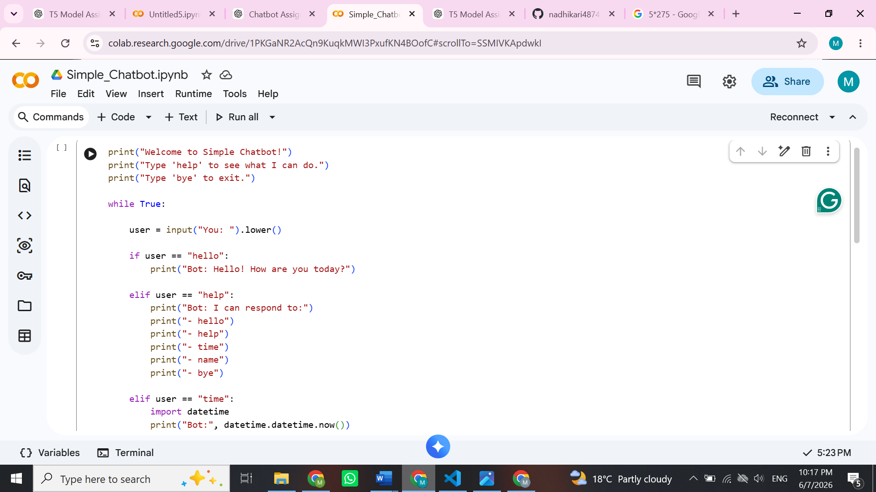
Figure 1. Python implementation of the rule-based chatbot.
Testing and Evaluation.
The verification of whether the system operates correctly under diverse situations is carried out with the help of software testing.
Many tests were performed to check the performance of chatbot.
Test Case 1: Greeting Command.
Input.
hello.
Expected Output.
Hi! How are you today?
Actual Output.
Hi! How are you today?
Result.
The chatbot successfully recognized the greeting command and generated the correct response.
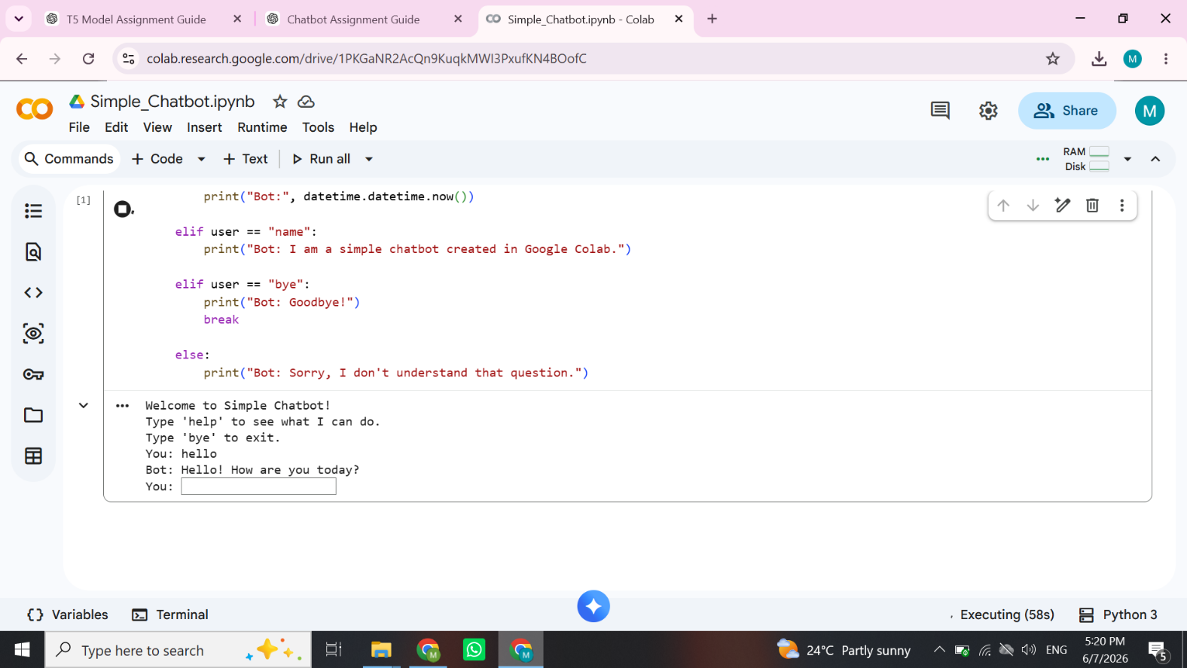
Test Case 2: Help Command.
Input.
help.
Expected Output.
Display supported commands.
Actual Output.
List of chatbot capabilities displayed successfully.
Result.
Pass.
Test Case 3: Time Command.
Input.
time.
Expected Output.
Current date and time.
Actual Output.
Current system date and time displayed correctly.
Result.
Pass.
Test Case 4: Name Command.
Input.
name.
Expected Output.
Display chatbot identity.
Actual Output.
I am a simple chatbot created in Google Colab.
Result.
Pass.
Test Case 5: Invalid Input.
Input.
banana.
Expected Output.
This is an error handling message.
Actual Output.
Sorry, I don't understand that question.
Result.
Pass.
Test Case 6: Exit Command.
Input.
bye.
Expected Output.
Conversation termination.
Actual Output.
Goodbye!
Result.
Pass.
The testing process confirmed that all chatbot functionalities operated as expected. Testing of the chatbot was performed on both valid and invalid user inputs and it performed well.
Screenshot 2: Help Command.
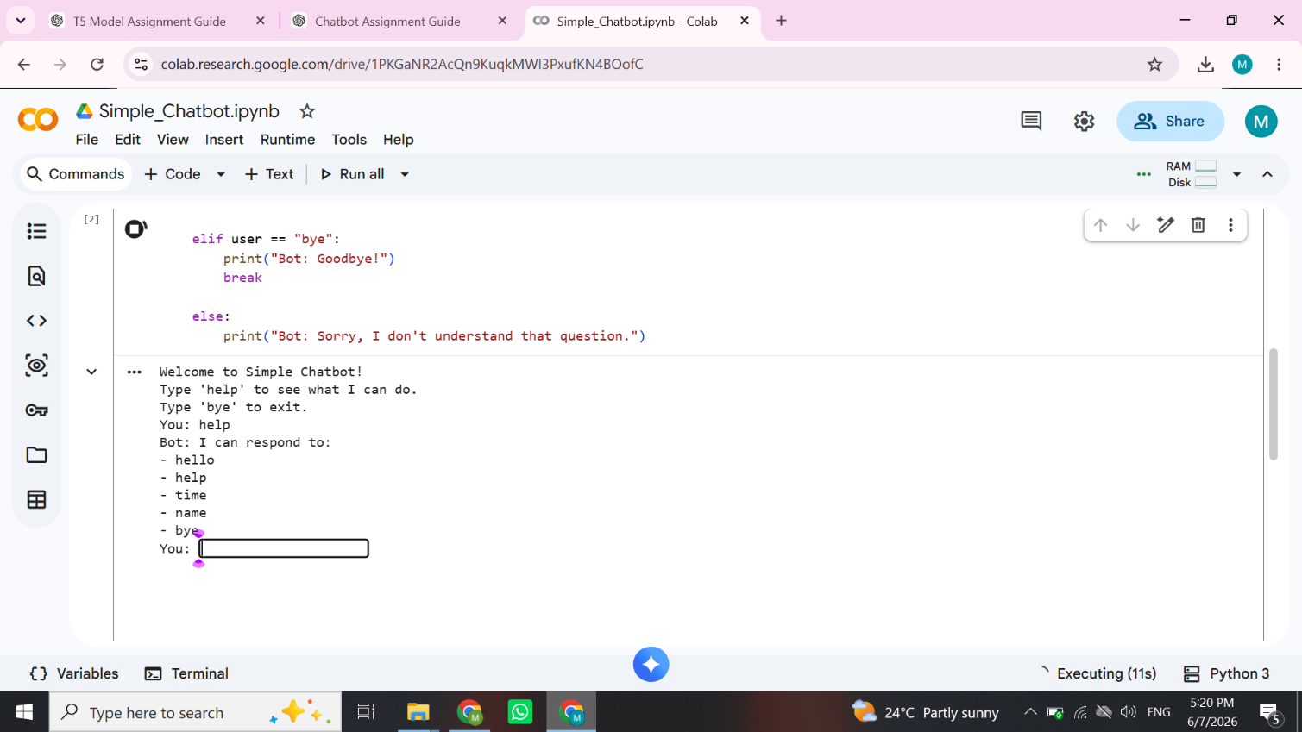
Figure 2. Chatbot displaying available commands.
Screenshot 3: Time Command.
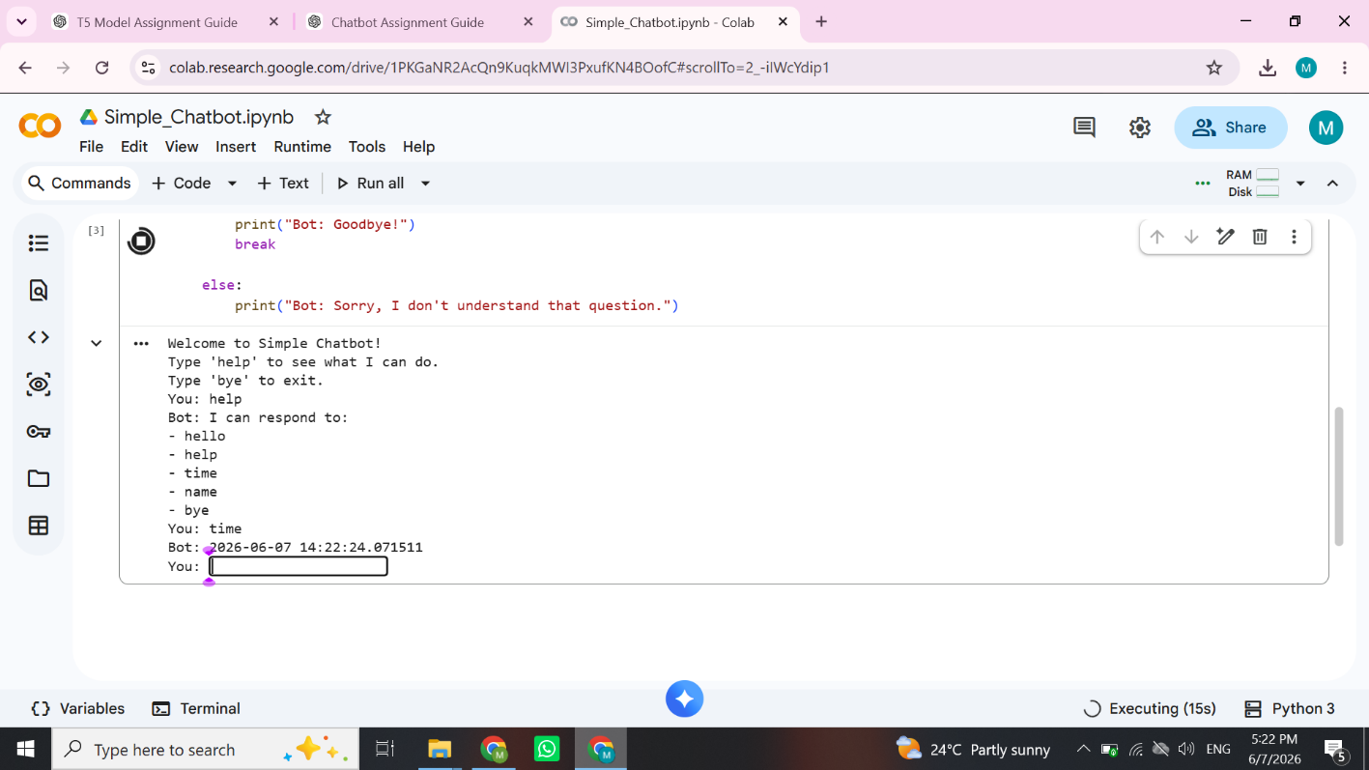
Figure 3. Chatbot displaying current system time.
Screenshot 4: Invalid Input Handling.
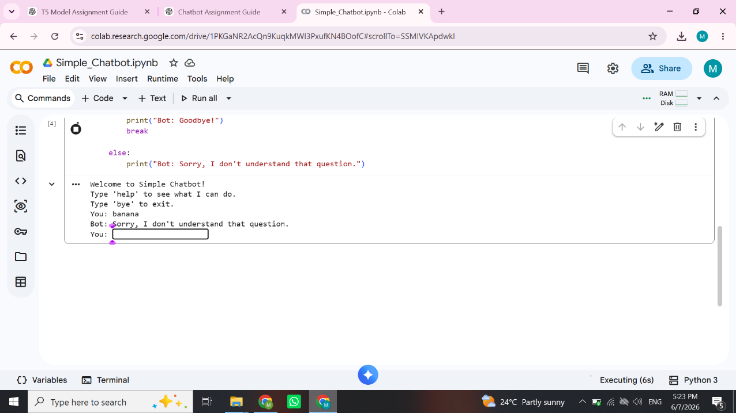
Figure 4. Chatbot handling unsupported user input.
Screenshot 5: Exit Command.
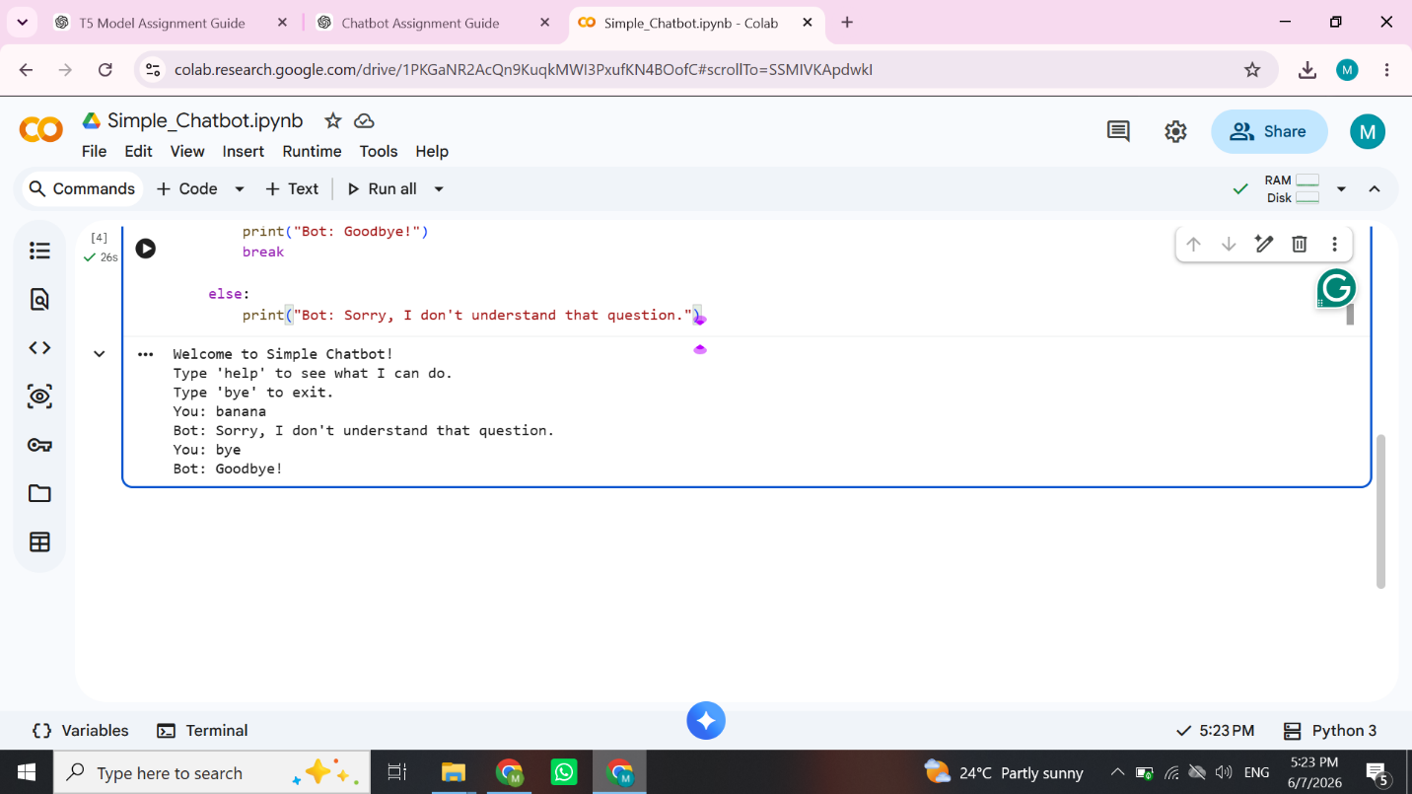
Screenshot with Bye Command Goes Here.
The chatbot ends the conversation in 2 kwowtime.
Challenges Encountered
Developing experienced several challenges during the development. Choosing the right development environment was the first challenge. Visual Studio Code, Anaconda and Google Colab all had been some options. The decision fell on Google Colab because it eased any installations to be done and the execution of the python code could begin directly without any local configurations. Ensuring consistent processing of user input presented another challenge. Users are allowed to enter commands that exhibit a range of capitalization patterns. This issue was solved by changing the case of all input to lowercase.
Managing invalid commands was also quite difficult. If not adequately validated, unsupported inputs may cause user trouble. This error-handling response enabled us to handle unexpected inputs appropriately. In the end, testing ensured that every command generated the expected output. The chatbot was subjected to several test cases to ensure it worked fine.
Future Improvements
Using specific examples or terms can harm the audience's vision. To begin with, the chatbot could incorporate natural language processing techniques to understand conversational language and not just predefined commands. Modern chatbots are powered by AI, machine learning and transformer architecture that generate responses within context (Friedman et al., 2024). Commands that can be added could enhance the working of the chatbots. Weather updates, calculator, educational assistant, information retrieval service, etc. are some examples. Third, we can use third-party APIs to see real-time information. Increased chatbot usefulness is possible with the functionality integrations.In the end, the chatbot could be a web application itself or could be integrated into messaging platforms to improve accessibility and user engagement.

